**Case Study #1 - Danny's Diner**

**Q1. What is the total amount each customer spent at the restaurant?**

**Ans : Query**

SELECT customer_id, sum(price) as total_amount from sales as sales_table left join menu as menu_table

on sales_table.product_id = menu_table.product_id group by customer_id;

example :

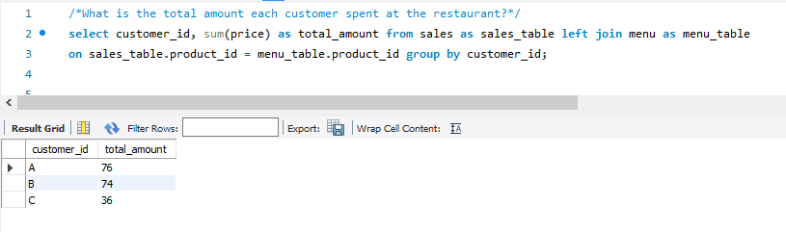

**Q2. How many days has each customer visited the restaurant?**

**Ans:**

SELECT customer_id, COUNT(DISTINCT order_date) as Count from sales

group by customer_id;

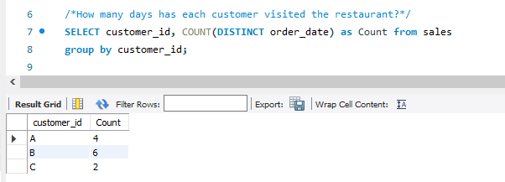

**Q3. What was the first item from the menu purchased by each customer?**

**Ans :**

SELECT customer_id, product_name

from (

SELECT sales.customer_id, menu.product_name, sales.product_id, sales.order_date,

row_number() over(PARTITION BY customer_id order by order_date) as rn

from sales join menu on sales.product_id = menu.product_id) as table1

where rn = 1

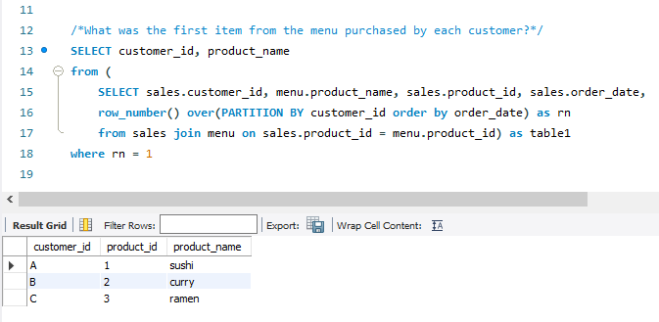

**Q4. What is the most purchased item on the menu and how many times was it purchased by all customers?**

**Ans**:

SELECT menu.product_name, count(sales.product_id) as count

from sales join menu on sales.product_id = menu.product_id

GROUP BY 1

order by count desc

limit 1

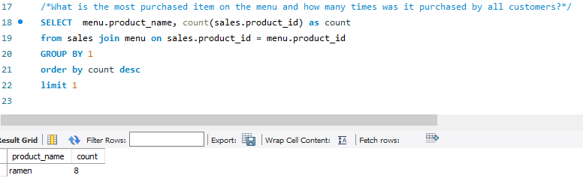

**Q5.? Which item was the most popular for each customer**

**Ans:**

with cte as (

select customer_id, product_name, count, max(count) over(partition by customer_id) as max_count

from(

select distinct sales.customer_id, sales.product_id, menu.product_name, count(sales.product_id)

over(partition by customer_id, sales.product_id order by customer_id) as count

from sales join menu on sales.product_id = menu.product_id

order by customer_id, count desc) x)

select customer_id, product_name, count from cte where count = max_count;

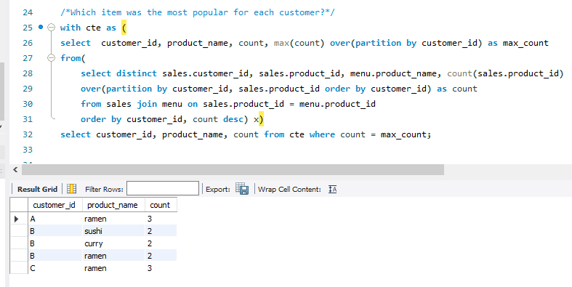

**Q6. Which item was purchased first by the customer after they became a member?**

**Ans:**

with cte as (SELECT sales.customer_id, product_id, order_date,

row_number() over(partition by sales.customer_id order by order_date) as rn

from sales join members on sales.customer_id = members.customer_id

where order_date>= members.join_date)

select cte.customer_id, cte.product_id, product_name, order_date

from cte join menu on cte.product_id=menu.product_id where rn = 1

order by customer_id;

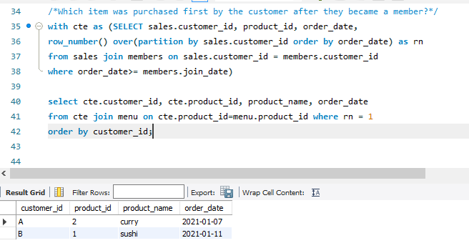

**Q7. Which item was purchased just before the customer became a member?**

**Ans**:

with cte as(

select sales.customer_id, product_id, order_date, join_date

from sales join members on sales.customer_id = members.customer_id

where order_date<join_date)

select cte.customer_id, cte.product_id, product_name, order_date,join_date

from cte

join menu m on cte.product_id=m.product_id

order by cte.customer_id;

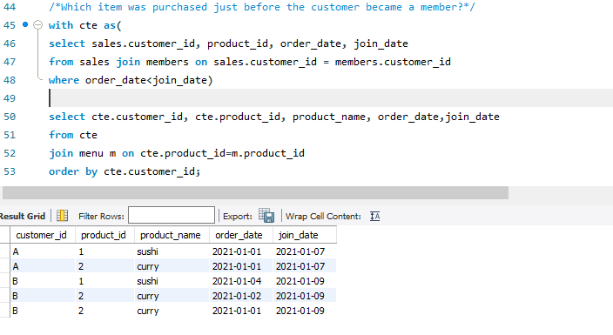

**Q8.What is the total items and amount spent for each member before they became a member?**

**Ans**:

select distinct sales.customer_id,

count(sales.product_id) over(partition by sales.customer_id) as total_items,

sum(price) over(partition by sales.customer_id) as total_amt

from sales

join members on sales.customer_id=members.customer_id

join menu on sales.product_id=menu.product_id

where order_date<join_date;

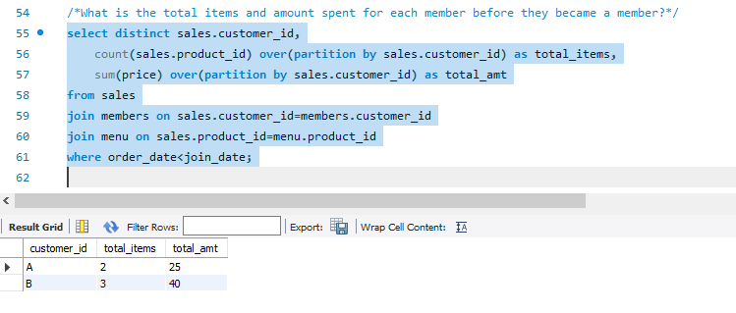

**Q9. If each $1 spent equates to 10 points and sushi has a 2x points multiplier - how many points would each customer have?**

**Ans:**

with cte as(

SELECT sales.customer_id, sales.product_id, product_name, price,

case when product_name = 'sushi' then price*20

when product_name != 'sushi' then price*10

end as points from sales join menu on sales.product_id=menu.product_id)

select distinct customer_id, sum(points) over(partition by customer_id) as total_points

from cte;

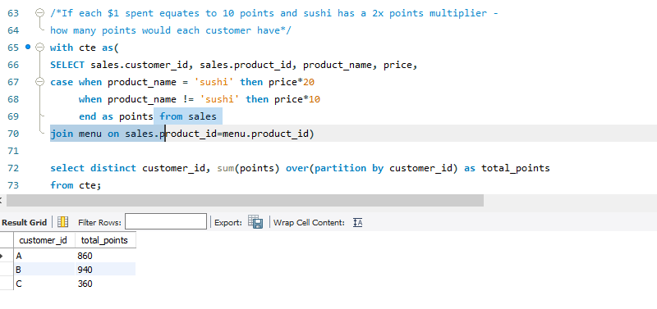

**Q10.**

**In the first week after a customer joins the program (including their join date) they earn 2x points on all items, not just sushi - how many points do customer A and B have at the end of January?**

**Ans:**

select distinct customer_id, sum(points) over(partition by customer_id) total_point

from(

select sales.customer_id as customer_id, order_date, price,

CASE when day(order_date) <=7 then price*20

when day(order_date) > 7 then price*10

end as points from sales

join members on sales.customer_id=members.customer_id

join menu on sales.product_id=menu.product_id

where order_date>= join_date and month(order_date)=1) x

